MINI PROJECT REPORT

***Healthify***

***Healthify***

A Thesis Report On

# 

# **SMART HEALTHCARE SYSTEM**

**Presented by,**

**Aditya Jogwar**

**Aparna Khadatkar**

**CONTENTS**

Chapter page no.

Introduction 3

Literature Review 4

Objective and Problem Definition 5

Study and Development of Healthify using Flutterflow 7

Methodology 9

Conclusion and Future Scope 15

References 16

**INTRODUCTION**

With the advancement of technology and scientific theory, traditional medicine with biotechnology as its core, has gradually begun to digitize and to informationize. Smart healthcare is not just a simple technological advancement, but also an all-round, multi-level change.

These changes mainly focus on meeting the individual needs of people while also improving the efficiency of healthcare industry and also represents the future development of the current medicinal healthcare system.

This report will consists of the main objective to design this system followed by the proposed technologies and the overview of the application.

Thus, in recent times, smart healthcare system has become a huge area of research interest.

**LITERATURE REVIEW**

**Aditya Jogwar et al [1]:** The main objective of this project is to make an efficient, user friendly application which will create awareness among people about healthcare technologies and help them as and when they require health guidance or treatments. This project will be mainly designed using a technology named Flutterflow where we will be using different widgets, search options, backend queries, integration with firebase, etc.

**Aparna Khadatkar et al [2]:** The main objective of this project is to make an easy to use application for any user irrespective of their age so that they can use application features anywhere and anytime and get benefited with it and make their and other people lives healthier. Especially for the needy people and for people in the rural areas which will provide them the instant data for any medical problem and health issues or they are also able to directly connect with the medical specialists.

**OBJECTIVE AND PROBLEM DEFINITION**

To study and develop a smart healthcare system to use for awareness and benefit of people, reduce time taking searching of people about healthcare.

The study will include finding the problem, designing a solution for the problem, development of the software and the final implementation and execution of the application.

# **Problem:**

Healthcare has been associated with in-person consultations for decades. This has been a problem that obligates the patients to run to the nearest healthcare center for treatment.

Now, the COVID outbreak and lockdowns made it even worse. So, what do they do if they need to see a doctor and have an emergency?

The need for a smart healthcare system is need of the hour and the solution is as mentioned below.

# **Solution:**

Mobile app developers continue to grow the flexibility and performance abilities of these remote-oriented platforms. This creates a reliable experience for medical experts to provide quality care and advice to patients from miles away.

Firstly, in terms of technology, we can accelerate the maturity and stability of related technologies through upgrades. Improving the ability to analyse information from big data is also important. Secondly, establishing a unified technical standard to achieve maximum compatibility between different devices and platforms is important.

Firstly, in terms of technology, we can accelerate the maturity and stability of related technologies through upgrades. Improving the ability to analyse information from big data is also important. Secondly, establishing a unified technical standard to achieve maximum compatibility between different devices and platforms is important.

**PROPOSED SYSTEM**

We are proposing a smart healthcare system which will help to develop awareness among people and help them to treat people (mainly home treatments) as and when required.

TOOLS & COMPONENTS:

|  |  |
| --- | --- |
| Components | Tools |
| Login & Registration Page | Firebase |
| Medical Consultation using Appointments(Home page) | Bottom Sheet in Flutterflow |
| Precautions | Buttons, Widget, Page, Container |
| Treatments | Buttons, Widget, Page, Container, Image Processing, List view. |
| Diet and Nutrition Plan(Home page) | Buttons, Page, Container, YouTube Player |
| Technical Support | Buttons, Contact Information, Email Information |
| Emergency Health Information | Widgets, Emergency Helpline Numbers |
| Doctor Information and Review | Widgets, Page, Container, Some Doctors Information |
| Feedback Form | Google Forms, Launch URL page, widgets. |

**METHODOLOGY**

The issue going on with the health care industry is lack of awareness among the consumers. We identified this issue and started working on creating a user friendly, easy to use application.

The platform that we proposed to use is:

**FRONTEND: FLUTTERFLOW**

**BACKEND: FIREBASE**

**Services used**

1. Widgets

2. Authentication service of firebase & Flutterflow.

3. Actions of Flutterflow

4. Backend Queries using Flutterflow

5. Parameter passing used in Flutterflow

6. Integration Service of Flutter flow.

## **Steps followed**

# **RESULTS AND DISCUSSION**

Our study is based on creating a user friendly and an application which can mainly create awareness among the consumers to use healthcare technologies effectively. In this module, we have shown how the application will work.

There are some services in our application which are available on navigation bar. The images of those modules are listed below.

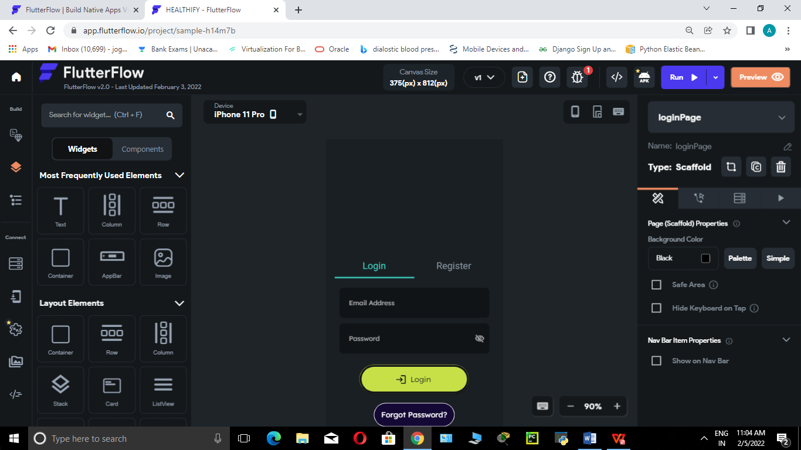. 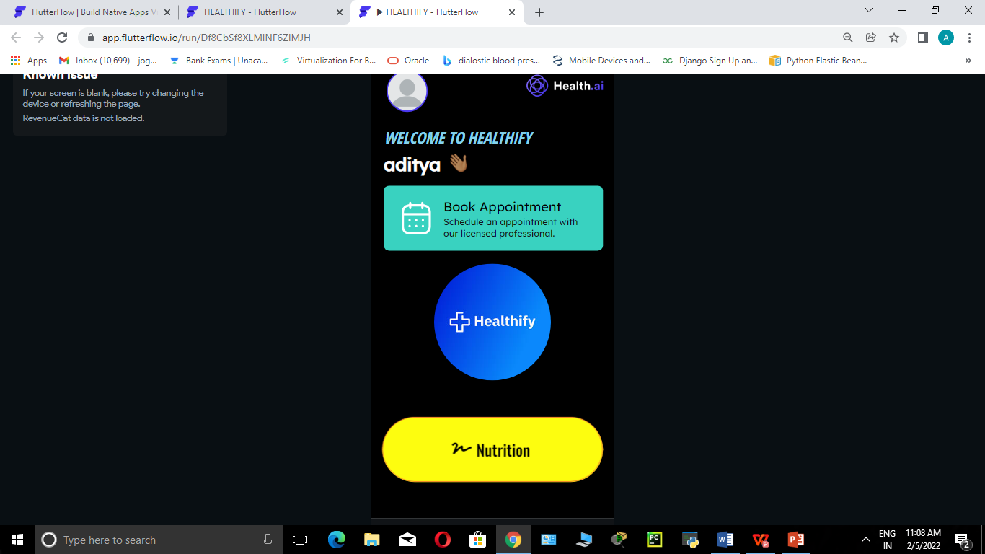 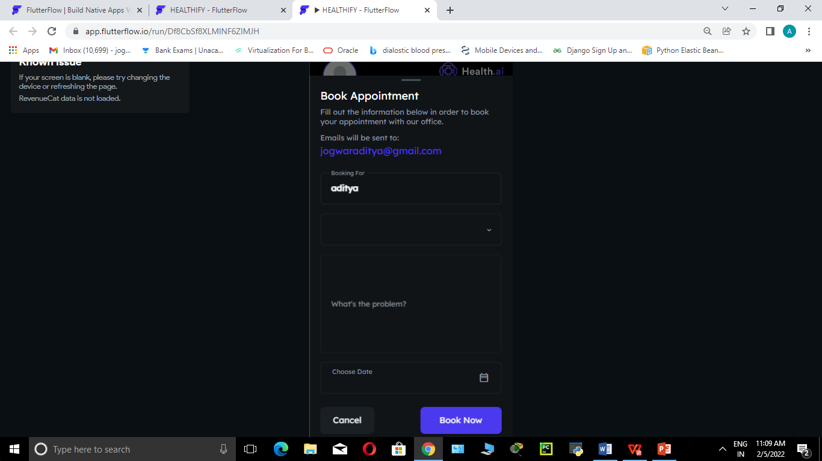

**FEATURES ON NAVIGATION BAR**

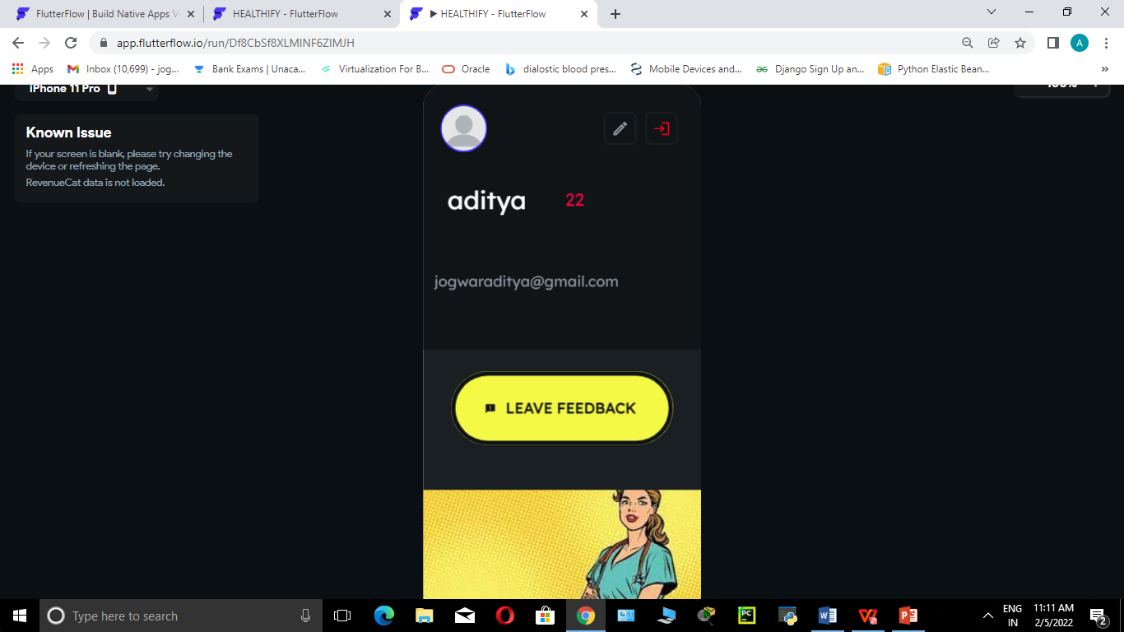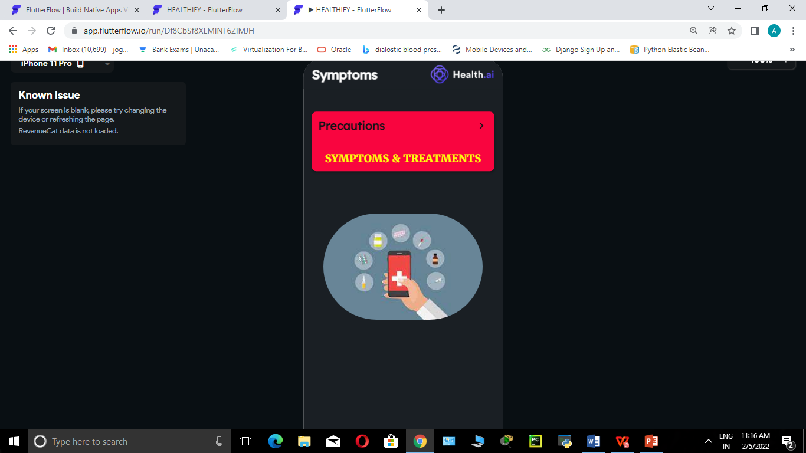

precautions & treatments

profile & feedback

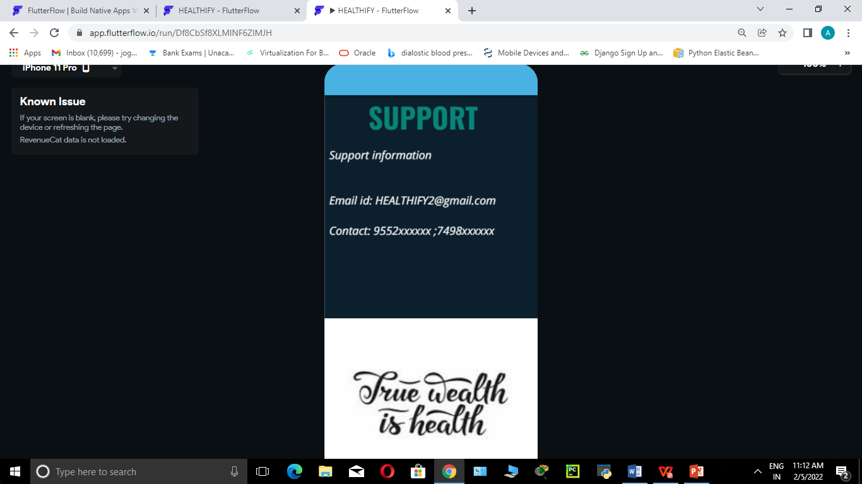

TECHNICAL SUPPORT

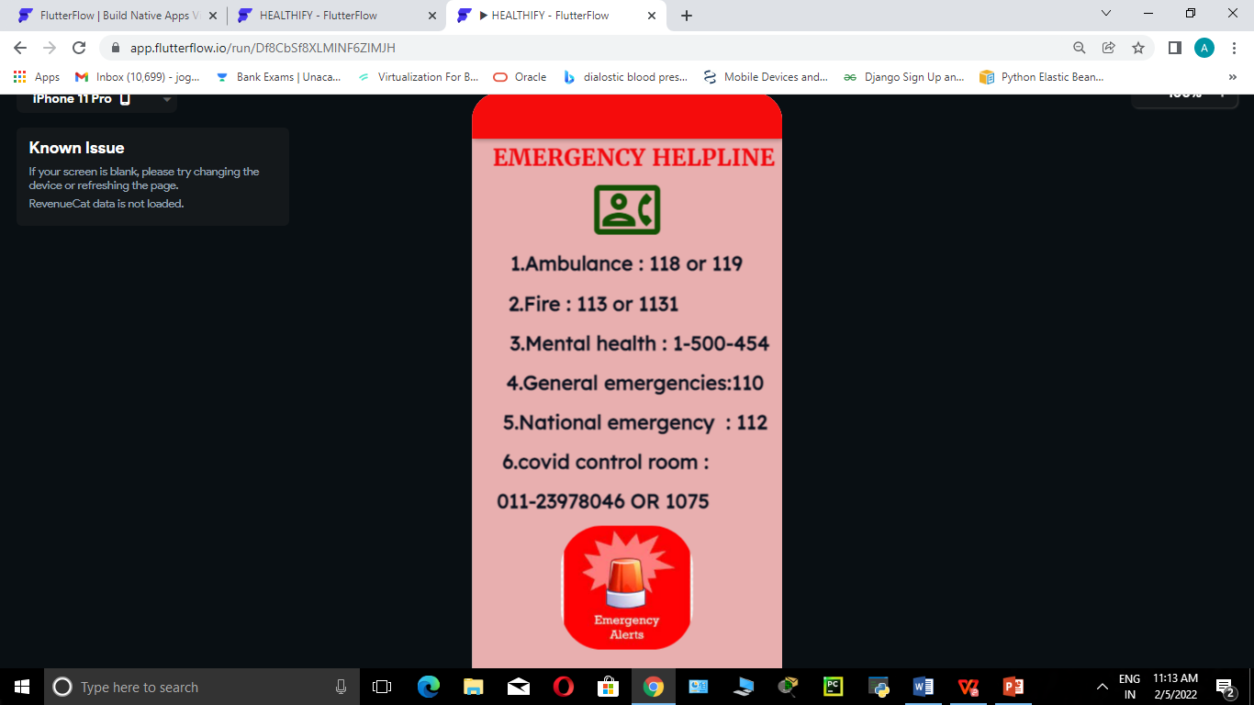

emergency helpline

# **Implementation Discussion:**

Using Flutter flow and Firebase, we have created an easy-to-use application which can be used by consumers who are needy and the application would also reduce time taking searching of some important healthcare data.

**CONCLUSION AND FUTURE SCOPE**

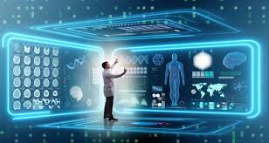**Health care** Technologies include medical devices that are used in home as well as digitally such as Home-Based healthcare.

The future scope in this area include:

1. **Regulating technologies** for healthcare consumers.

2. **Developing Awareness** among people about healthcare technologies.

3. **Privacy and security** of data.

4. Ensuring that consumers who are **needy** get **benefited** from these technologies.

# 

# **REFERENCES**

1. Flutterflow Official Website for documents**: <https://docs.flutterflow.io/>**
2. Firebase Documents**: <https://firebase.google.com/docs/>**
3. Flutterflow Basics**:**

**<https://www.youtube.com/watch?v=39y_VgNDvok&t=744s>**

1. Firebase Console and Services**: [https://firebase.google.com/](https://firebase.google.com/docs/)**
2. Flutterflow UI Builder**: <https://flutterflow.io/>**
3. Google Cloud API Services**: <https://console.cloud.google.com/google/maps-apis/api-list?project=healthify-bcb9e>**